20.63: a) For an ideal gas, 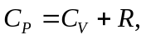 and taking air to be diatomic, 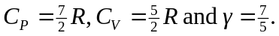 Referring to Fig. (20.6), Similarly, 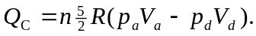 What needs to be done is to find the relations between the product of the pressure and the volume at the four points.
For an ideal gas, 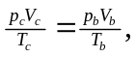 so 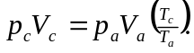 For a compression ratio r, and given that for the Diesel cycle the process ab is adiabatic,
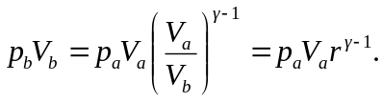
Similarly, 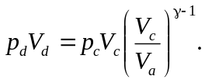Note that the last result uses the fact that process da is isochoric, and 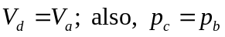(process bc is isobaric), and so 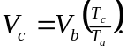 Then,
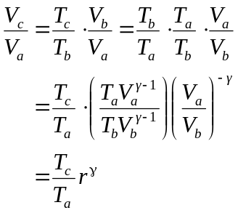

Combining the above results,
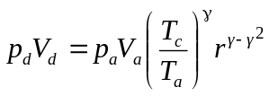
Subsitution of the above results into Eq. (20.4) gives

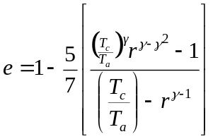
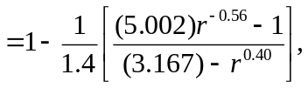
where 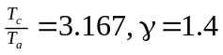 have been used. Substitution of 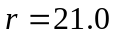 yields 